2016
A survey examining business attitudes towards the European Union in the run up to the Referendum
EU Business Survey
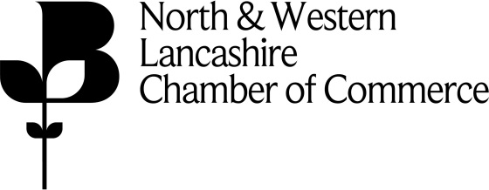
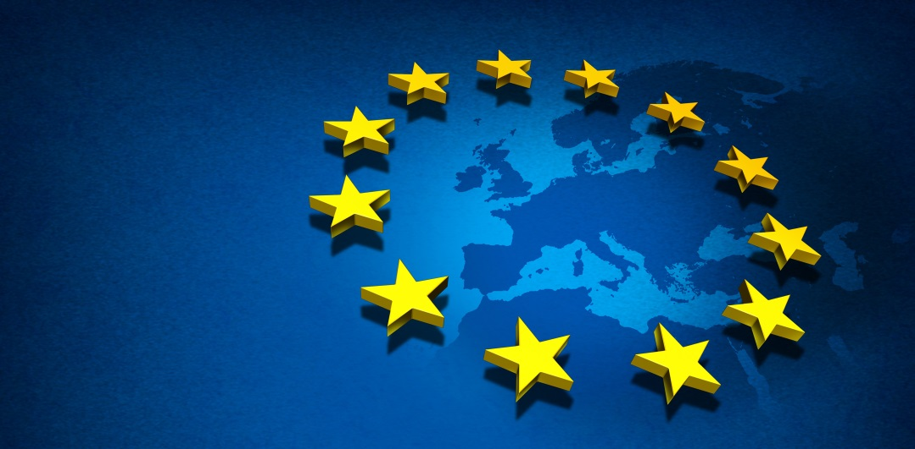
+
1. Introduction

In 2015 the Europe Direct Information Centre for Lancashire commissioned a report to gauge the attitudes by businesses in the county to the European Union (EU). It took a detailed look at how local businesses viewed this relationship and how they wanted to view the EU moving forward. The report also measured the impact that the EU had on their operations including the issue of migrant workers.

The purpose of this 2016 EU Business Survey is capture the mood of the same businesses using the same questions to see if there has been any shift in attitude ahead of the Referendum on the 24 June. Irrespective of the result the outcome will have a significant impact on the UK's business relationship with the EU.

It’s therefore important that we are able to understand how the Lancashire business community view this relationship and how it sees its relationship with the EU which, with 23 million SME’s and 500 million citizens represents the world’s biggest trading block developing in the future

The survey was undertaken in conjunction with the North and Western Lancashire Chamber of Commerce and we thank our colleagues there for their help and support. The results from the previous year’s findings are in brackets to ease of comparison.

We hope you find the report both interesting and informative.

This report was commissioned by North and Western Lancashire Chamber of Commerce as part of their Europe Direct Centre Action Programme. The Report offers a fascinating insight into the changing views of Lancashire businesses.

The Europe Direct information centre (EDIC) network, of which the Chamber is a part, stretches over the 28 EU Member States including 15 in the UK, providing outreach points for all the EU institutions, complementing and supporting the work of the European Commission Representation and the European Parliament Information Office at local and regional level.

Each Europe Direct centre plays an important part in providing information, promoting participatory citizenship, stimulating debate and encouraging feedback.

This survey, directed at businesses in Lancashire is a valuable tool for gauging views in the region. Given that one of the Commission’s key priorities is on jobs and growth, the concerns and interests of the business community are of real importance to policy makers.

Although the results highlight points on which local businesses would welcome reform, it is clear from this survey that the European Union is still considered of significant value.

2. About the North and Western Lancashire Chamber of Commerce
North and Western Lancashire Chamber of Commerce is the largest financially and politically independent business support organization in Lancashire. We have a membership base of over 1500 local companies who own, manage, and finance our business support services.
We are a fully accredited member of the British Chambers of Commerce (BCC). The BCC represents, through a quality assured, UK network of Accredited Chambers of Commerce, more than 135,000 businesses in all sectors of the economy, and of all sizes. Accredited Chambers seek to represent the interests and support the competitiveness and growth of all businesses in their communities and regions.
3. About Europe Direct

Europe Direct is an information network of approximately 480 centres across Europe, designed to answer all enquiries relating to the European Union.

The Lancashire Europe Direct Information Centre is based at North and Western Lancashire Chamber of Commerce. In addition to providing advice to the wider community the Centre also increases the depth of the Chamber’s international and inward investment services. The service is available to all regional businesses and their employees.

4. Summary of Key Findings:

40% (43%) agreed that the UK has benefited significantly from being a member of the European Union.

35% (33%) agreed that membership of the EU has done more good than harm.

10% (8%) agreed with the statement that the UK had been damaged by EU membership.

49% (57%) were in favour of the UK remaining a member of the EU but wanted to see fewer decisions taken by the EU as a whole. 18% (22%) were in favour of maintaining the UK’s existing relationship with the EU. 16% (13%) were opposed to the UK staying in membership of the EU.

When asked which scenario would have the most positive impact on their business;
44% (47%) said remain in the EU but transfer powers back to the UK
20% (24%) said no change
16% (18%) said integrate further
20% (11%) said withdrawing from the EU

When asked which scenario would have the most negative impact on their business;
54% (59%) said withdrawing from the EU
16% (18%) said further integration
18% (15%) said no change
12% (8%) said remain in the EU but transfer powers back to the UK

On the importance of creating a common European policy on key issues, creating a deeper and fairer single market was still viewed as the top priority. Establishing a balanced free trade agreement with the US was the second most important policy area (although this depended on which party was in office and held power), followed by a common security and defence policy in third.

Which of the EU’s four basic "freedoms" is there the greatest need for further action and reform?
40% (37%) said free movement of persons
37% (35%) said free movement of goods
17% (20%) said free movement of services
6% (8%) said free movement of capital

Of those involved in exporting, 79% (81%) said that the EU was a key market for their business; well ahead of the Middle East in second 43% (45%).

73% (75%) of businesses welcomed people from EU member states coming to work in the United Kingdom, whilst 20% (17%) were opposed.

Only 15% (18%) of those responding had recruited from overseas in the past year. A shortage of candidates with relevant experience was still the most common reason businesses employed migrant workers remaining unchanged at 75%.

5. Methodology

The results from this survey are drawn from a joint Chamber and Europe Direct research project undertaken during March and April 2016 contacting the same 77 businesses and asking the same questions as for the 2015 survey.

6. Breakdown of respondents by number of employees

Surprisingly the same 77 businesses responded to the survey being happy to be used as a barometer for the county. These have been broken down into the following size categories.

11 – 50 employees 25%
51 – 250 employees 42%
250 + employees 33%

Half the respondents were from the manufacturing sector. The remaining 50% were from the transport and communications sectors (20%), business and professional services (10%), industrial services (10%), and public administration (10%).

7. Survey Results

Question 1 asked respondents for their overall view of the UK’s membership of the EU.

40% (43%) of respondents considered that the UK has benefited significantly from being a member of the EU with a further 35% (33%) believing that membership has done more good than harm.

15% (16%) of respondents considered that membership of the EU had done more harm than good whilst a further10% (8%) believed that the UK had been damaged by being a member.

In total 75% (76%) of respondents believed that the UK had benefited from membership whilst 25% (24%) considered that it had not.

Question 2 asked respondents to describe their attitudes towards future membership of the EU.

Answer Options | Response Percent
I am in favour of the UK remaining a member of the EU and would like to see more decisions taken by the EU as a whole | 6% (8%)
I am in favour of the UK remaining a member of the EU and would like it to remain as it is | 20% (22%)
I am in favour of the UK remaining a member of the EU but would like to see fewer decisions taken by the EU as a whole | 55% (57%)
I am against the UK's membership of the EU | 18% (13%)
Don't know | 1% (0%)
The majority of respondents 55% (57%) were in favour of the UK remaining a member of the EU but would like to see fewer decisions taken by the EU as a whole. 20% (22%) wanted to maintain the existing relationship, whilst 18% (13%) of respondents were against the UK’s membership of the EU.

Question 3 asked respondents to indicate their preferred option for the EU going forward.

Answer Options | Response Percent
An integrated political community working on behalf of both nations and Europe as a whole | 20% (21%)
An integrated "United States of Europe" working on behalf of European citizens and businesses | 18% (19%)
A free trade area such as EFTA | 51% (48%)
No EU at all but a group of independent nations working together on certain common issues | 8% (5%)
Don't know | 3% (7%)

Question four asked respondents which of five scenarios would have the biggest negative impact on their business.

Completely withdrawing from the EU was seen as having the biggest negative impact on business 54% (55%) of respondents. Further integration with the EU was seen as the second most negative impact 16% (19%). The least negative scenario presented was withdrawal from the EU and negotiating a new trade deal, only 5% (4%) felt this would have a major negative impact on their business.

Question five asked respondents which of the same five scenarios would have the biggest positive impact on their business.

44% (47%) of respondents said that “remaining in the EU but transfer powers back to the UK” would have the most positive impact.

16% (18%) said further integration would have the biggest positive impact.

Question six considered the importance of creating a common European policy in certain selected areas: namely European and monetary union, energy, digital services, a deeper and fairer internal market, free trade agreement with the US, stricter controls on banks, asylum and migration, defence, and justice and citizen rights.

Respondents were asked to rank each priority as High, Medium, or Low.

“Economic and monetary union” was rated as a High priority by 34% (36%) of respondents, 31% (30%) rated it a Medium priority and 35% (34%) as a Low priority.

“Sustainable and secure energy union” was rated High by 38% (39%) of respondents, 48% (50%) as Medium, and 13% (11%) as Low.

“A connected digital single market was rated High by 39% (37%), Medium by 46% (47%) and Low by 15% (16%).

“A deeper and fairer internal market” was rated High by 65% (64%) (the top rating overall), Medium 28% (30%), and Low 7% (6%) (the lowest rating overall).

“A balanced free trade agreement with the United States” was rated High by 55% (54%), Medium 36%, (38%), and Low (8%).

“Stricter controls on banks” was rated High by 53%, (52%), Medium 31% (33%), and Low 17% (16%).

“Asylum and legal migration” was rated High by 54% (53%), Medium 30% (32%), and Low 12% (11%).

“Security and defence” was rated High by 51% (52%), Medium 37% (37%), and Low 12% (11%).

“Justice and fundamental rights for citizens” was rated High by 47% (48%) , Medium 29% (28%), and Low 23% (23%).

Question 7 looked at the EU’s four freedoms (free movement of persons, free movement of goods, free movement of services, and free movement of capital) and asked respondents which of them was in need of further action and reform.

40% (37%) of respondents stated that the free movement of persons was in greater need of reform. This was followed by free movement of goods 37% (35%), free movement of services 17% (20%) and finally free movement of capital 6% (8%).

Questions 8 and 9 asked how well-informed respondents were about the potential impact of EU legislation and policy measures on their business and where they would go to access the necessary information.

68% (66%) of respondents considered themselves as “fairly well informed”, 18%, (22%) as “not at all informed” and 14% (12%) “very informed”.

When asked about accessing information 55% (58%) of respondents would use the EU website followed by the Chamber of Commerce 56% (55%). 17% (15%) of respondents would use Europe Direct, 7% (8%) their local authority, and 5% (3%) their library.

Questions 10 and 11 asked respondents if they were currently exporting and, if so, to which countries.

Over 63% (60%) of respondents were exporting of which 79% (80%) stated that the EU was their most important market followed by the Middle East 45% (44%) and North America 39% (37%) and the Middle East 45% (37%). Less than one quarter of respondents 20% (24%) considered the BRIC trading bloc to be one of their most overseas markets.

Questions 12 to 17 focused on immigration and the use of migrant workers.

Question 12 asked whether businesses welcomed or opposed people from EU member states coming to work in the UK.

Question 13 and 14 asked whether respondents had recruited staff from overseas in the past 12 months and, if so, from which countries.

Just over 15% (17%) said they had recruited staff from overseas in the last 12 months, with all of those recruiting having taken on people from within the EU. 27% (25%) of companies recruiting from abroad employed people from non-EU states; whilst 13% employed people from the Commonwealth and the Rest of the World.

Question 15 asked the reasons for employing migrant workers. Three quarters of respondents as per the previous survey recruited because of a short supply of candidates with relevant experience and half recruited because of a short supply of candidates with the relevant skills.

Question 16 looked at working hours. Over 80% (83%) of jobs offered to migrant workers were for full time jobs. One third were temporary and one quarter were for permanent jobs as per the 2015 survey

Question 17 looked at the types of jobs offered. Respondents reported that two thirds of all jobs were either professional and managerial 34% (33%) or skilled manual and technical 35% (33%). The remainder were for unskilled or manual labour.

Conclusions

The significant conclusion to be drawn from this survey is that Lancashire firms take the view that whatever happens in terms of the UK’s relationship with the EU they will continue to trade and look for new export markets. Should the UK vote to remain within the EU the EU then trade with our biggest trading neighbour will continue. However should the UK vote to leave and as this survey shows since the 2015 survey key businesses leaders within the county are hardening their attitudes towards the EU, they will simply switch to other more lucrative markets in the Middle and Far East where there is a demand for premium priced UK products and there is more economic growth. There has been a clear shift downwards in attitude from the 2015 survey towards the positive impact of the EU upon their businesses. However in some responses it is inter4wsting to note that the chance is only 1 or 2% demonstrating little changes in some areas.

Businesses continue to tell us, that for the UK to remain in the EU significant reforms will be needed involving as in the 2015 survey a sizeable transfer of power back to national parliaments

Less than 25% as before wanted to continue with the current arrangements of no change in relationship between the EU and the UK.

It’s also clearly apparent that the EU remains a significant trading block for Lancashire businesses Given that over three quarters of exporters responding to the survey report that the EU is their most important trading partner the clear priority for reform, unsurprisingly, is the creation of a deeper and fairer Single Market. Such reform should run in parallel with pursuing a balanced free trade agreement with the United States and Canada as well as the deepening refugee crisis and shift in global politics to the more nationalist right.

As reported in the 2015 survey the EU particularly Eastern European member states remains an important source of labour for Lancashire businesses and that the main reasons for this recruitment are because of a shortage of skilled and experienced applicants in the UK or an unwillingness for UK applicants to fill certain positions.

The 2015 Survey demonstrated that a number of businesses believed the UK has benefited to some degree from being a member of the European Union and while this is still the case the margin is rapidly being eroded away.

